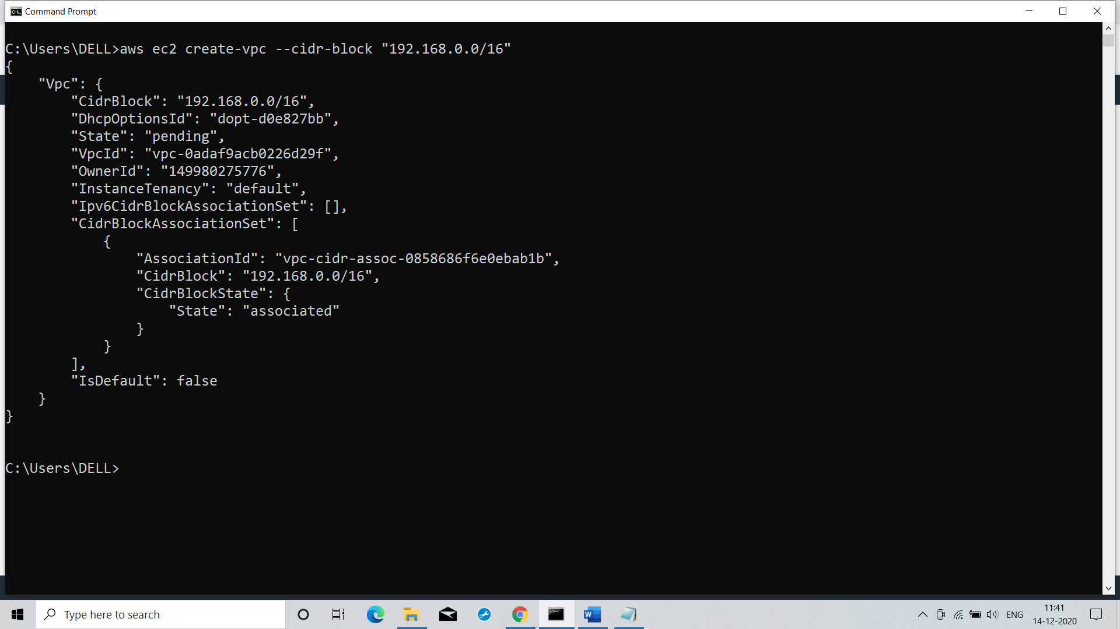

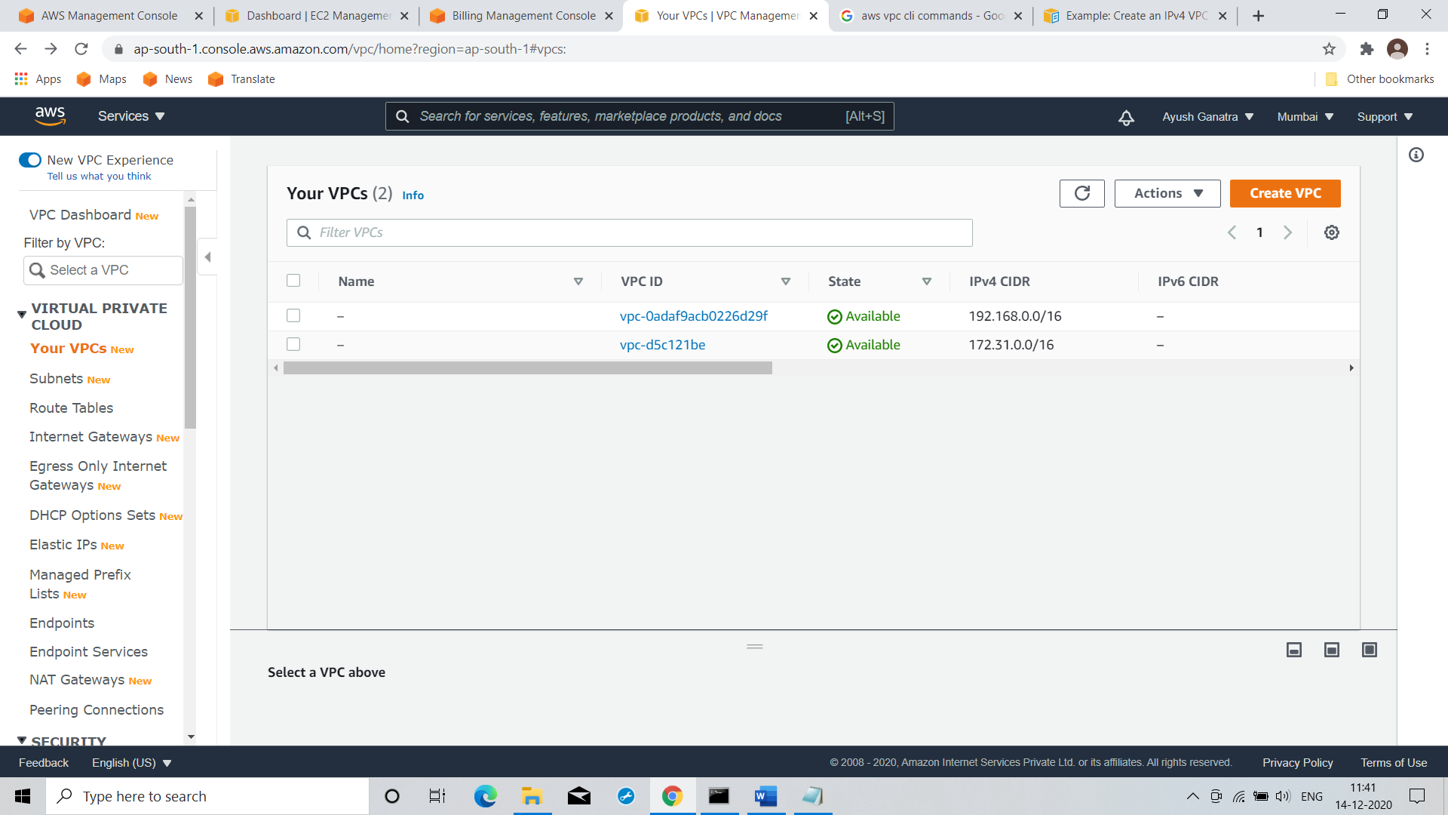

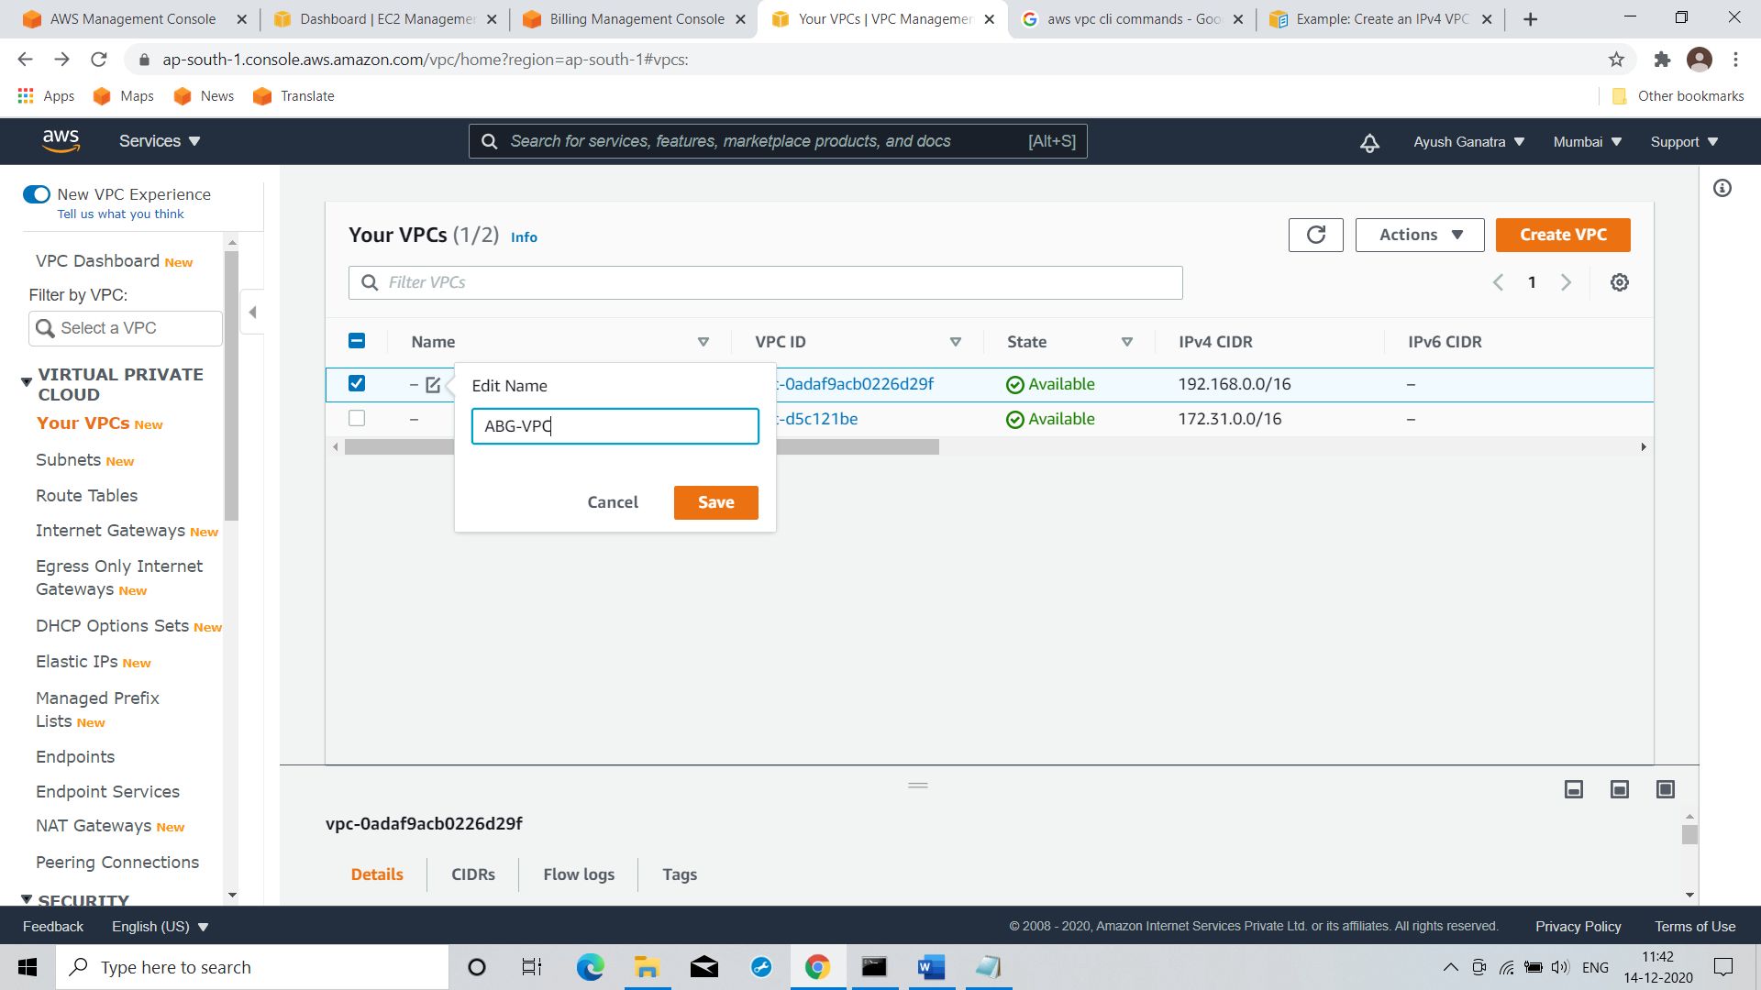

Command: aws ec2 create-vpc --cidr-block "192.168.0.0/16"

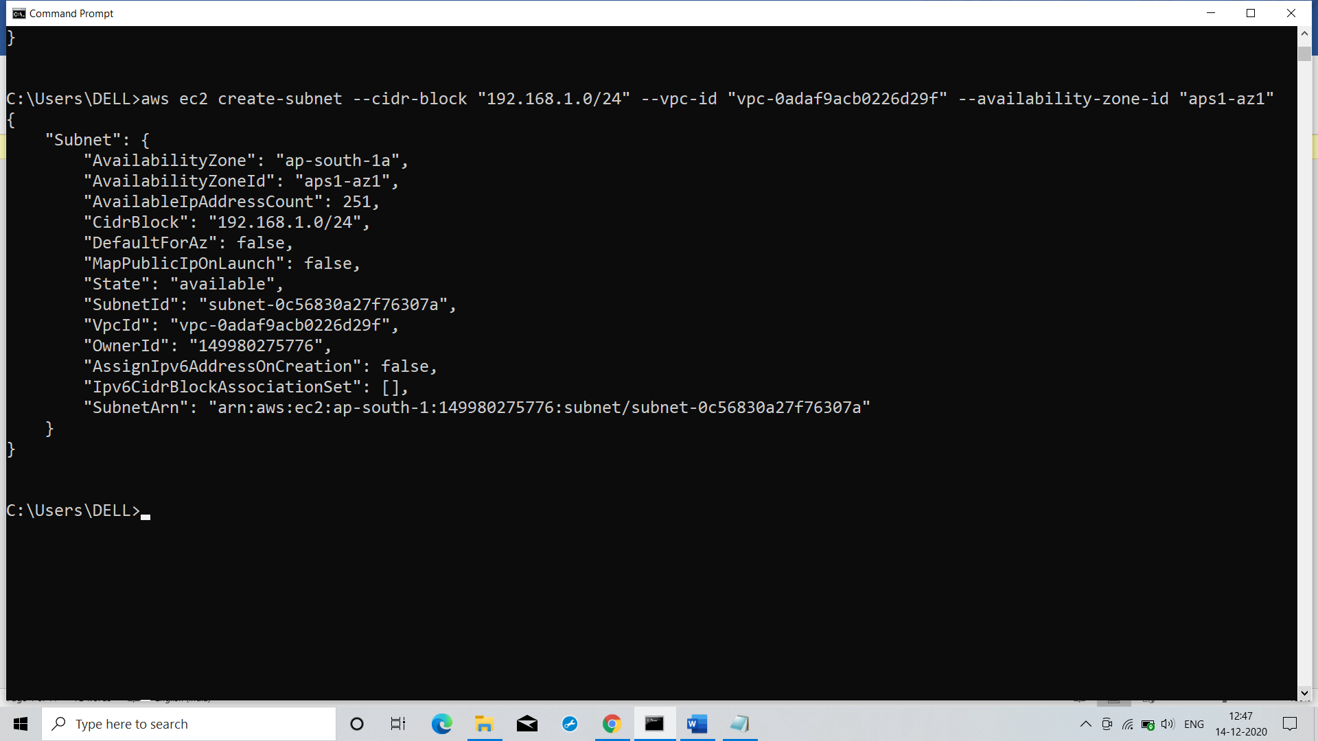

Command : aws ec2 create-subnet --cidr-block "192.168.1.0/24" --vpc-id "vpc-0adaf9acb0226d29f" --availability-zone-id "aps1-az1"

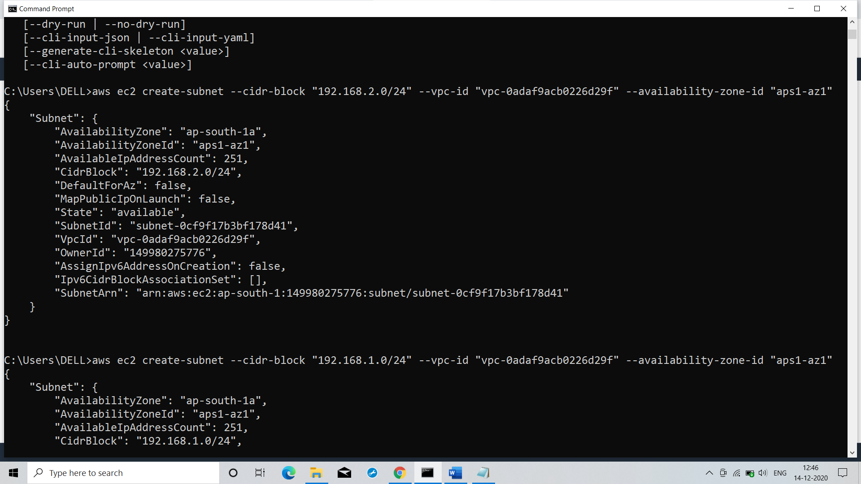

Command: aws ec2 create-subnet --cidr-block "192.168.2.0/24" --vpc-id "vpc-0adaf9acb0226d29f" --availability-zone-id "aps1-az1"

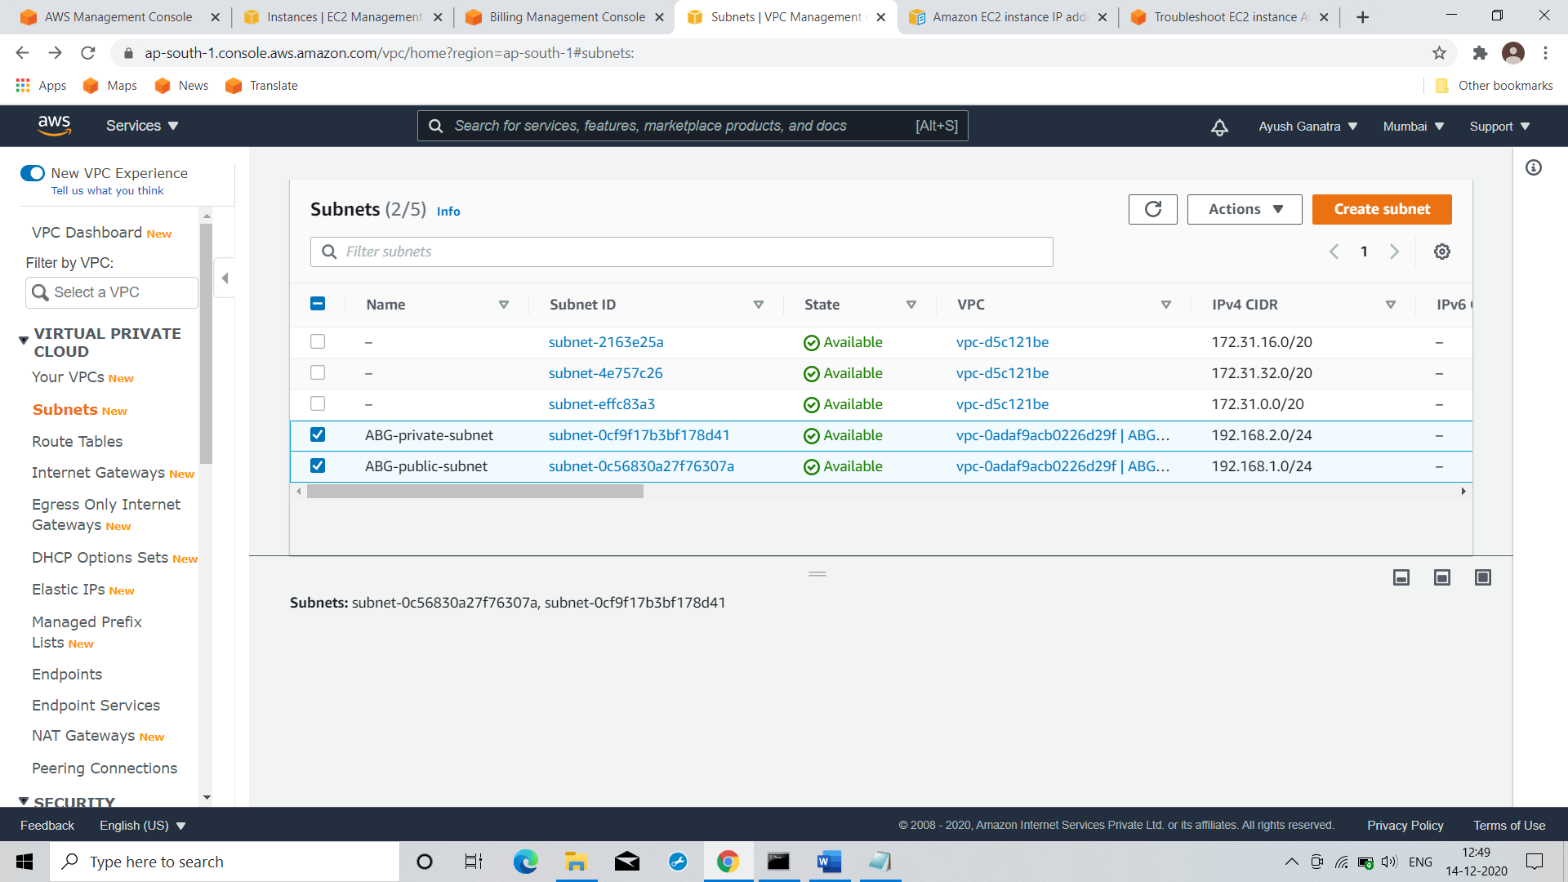

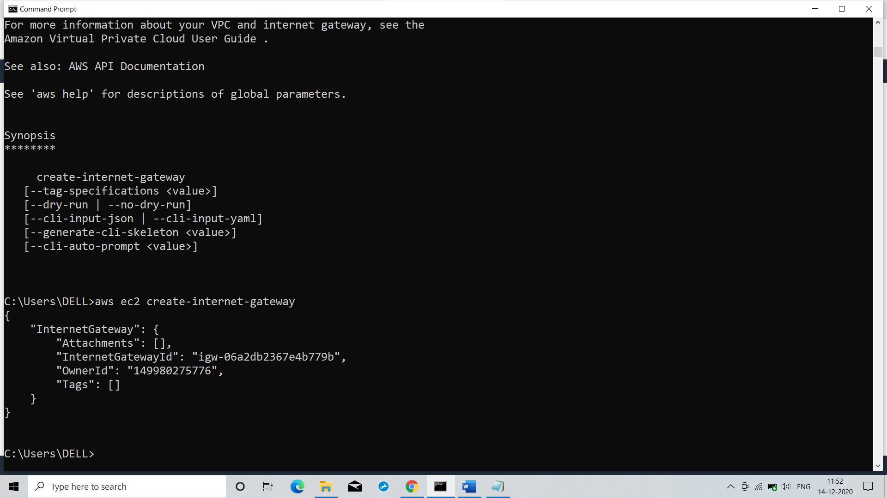

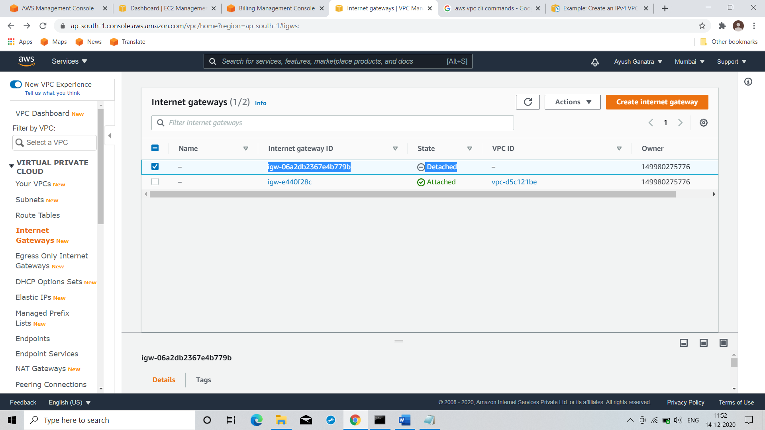

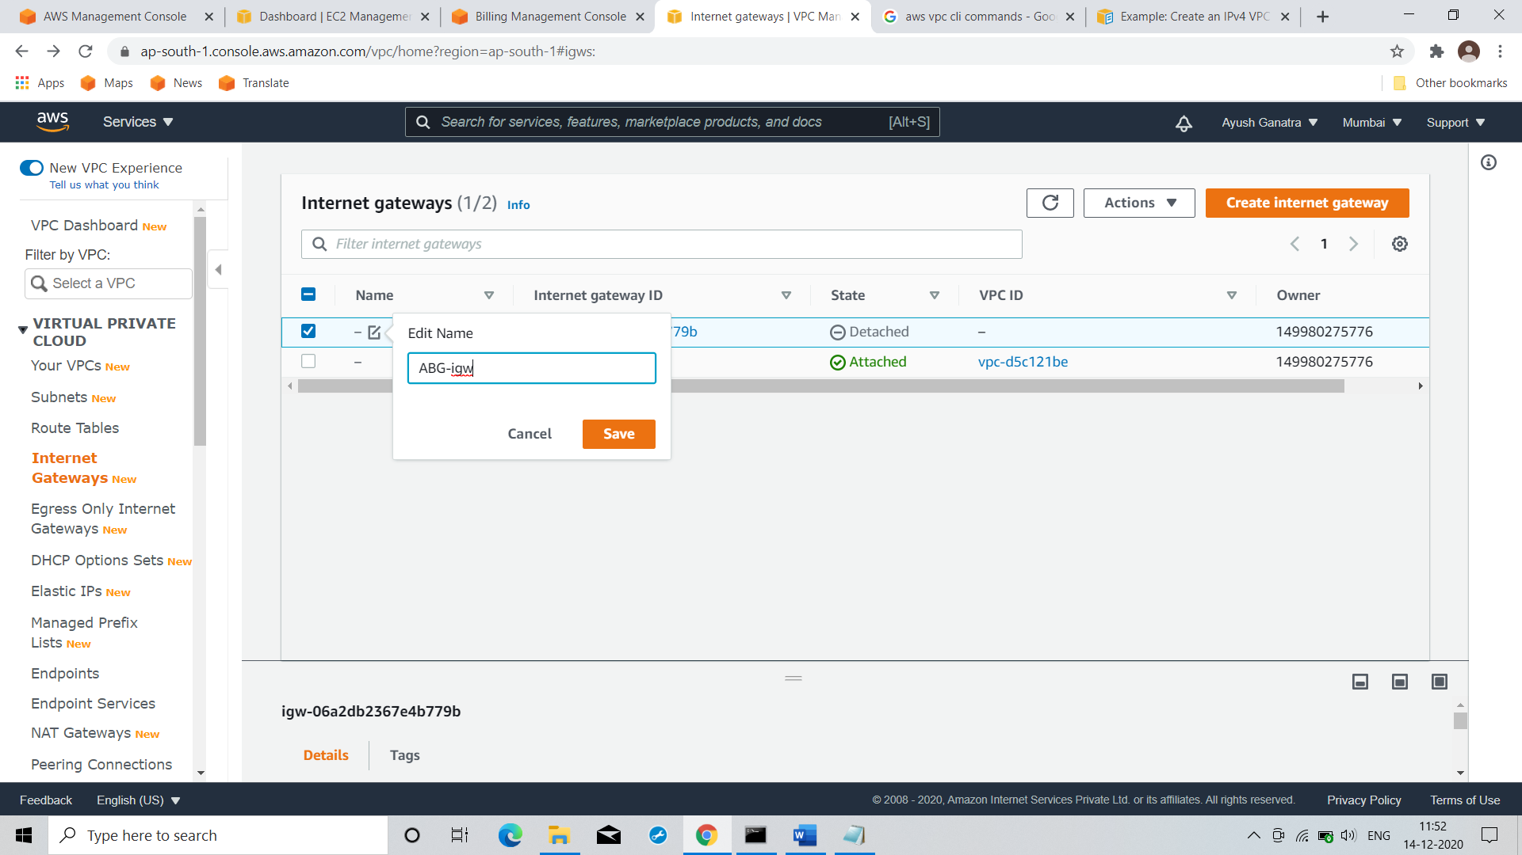

Command: aws ec2 create-internet-gateway

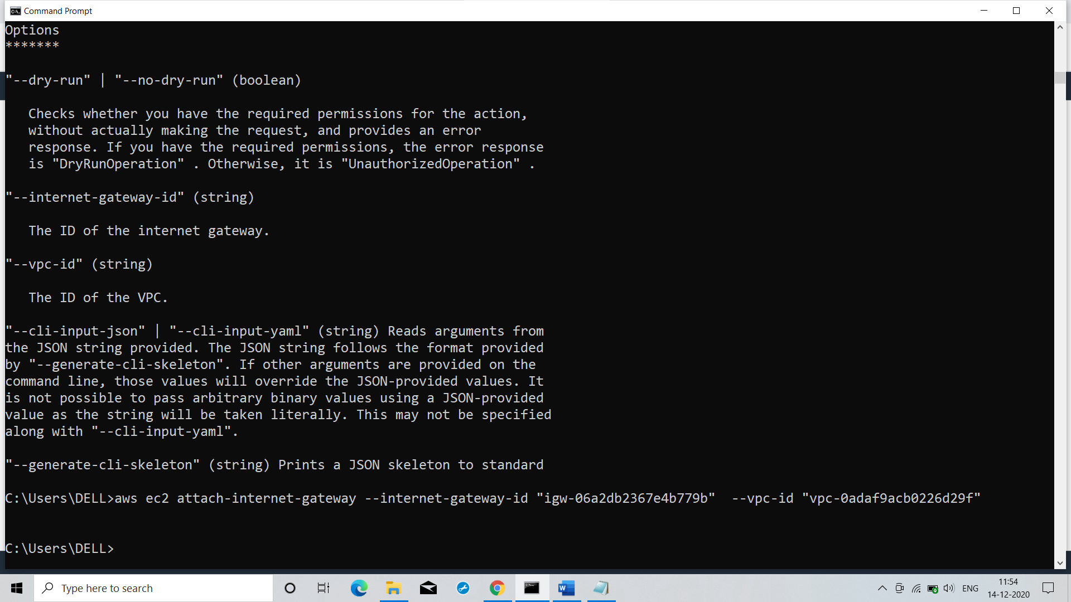

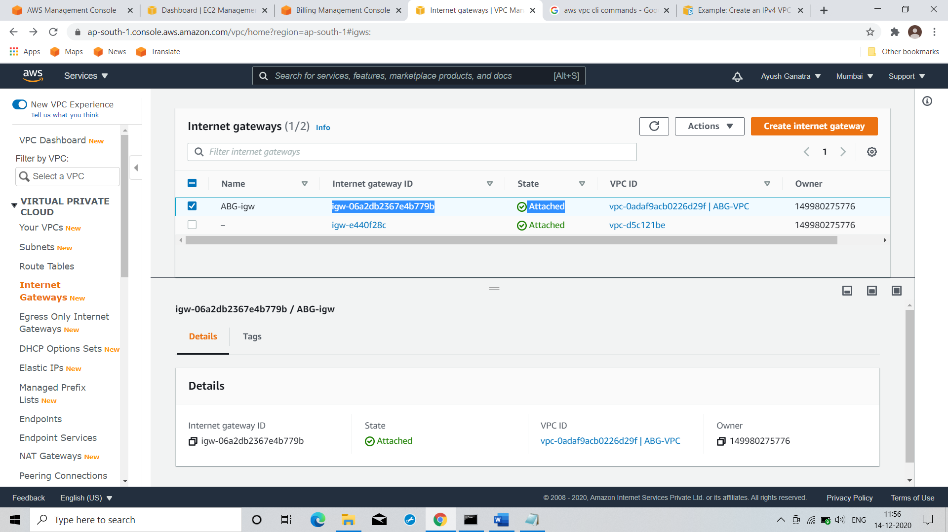

Command: aws ec2 attach-internet-gateway --internet-gateway-id "igw-06a2db2367e4b779b" --vpc-id "vpc-0adaf9acb0226d29f"

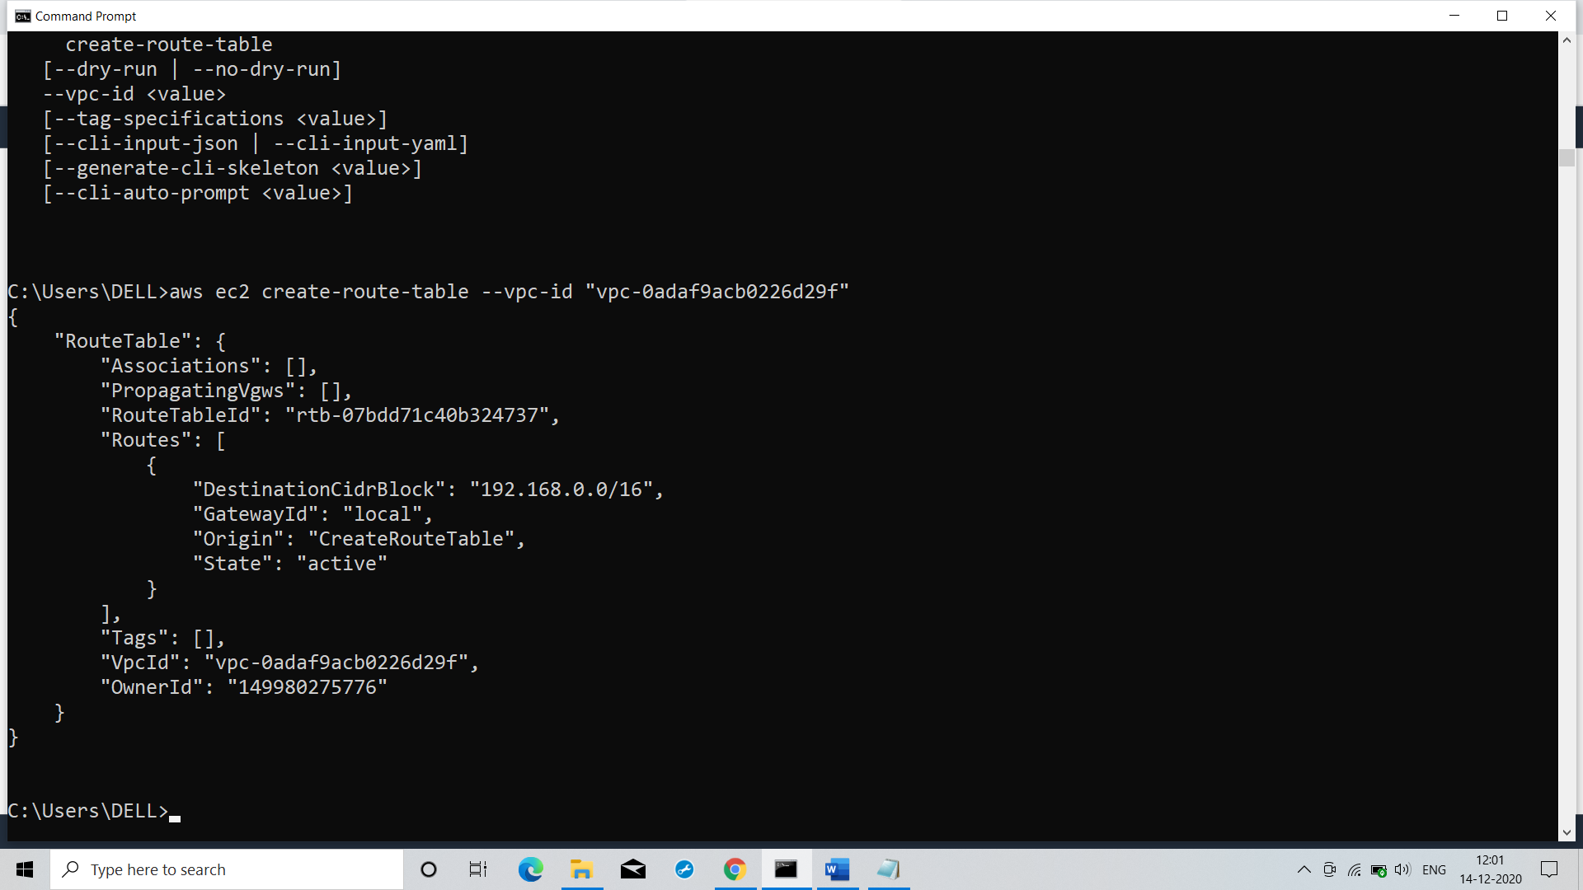

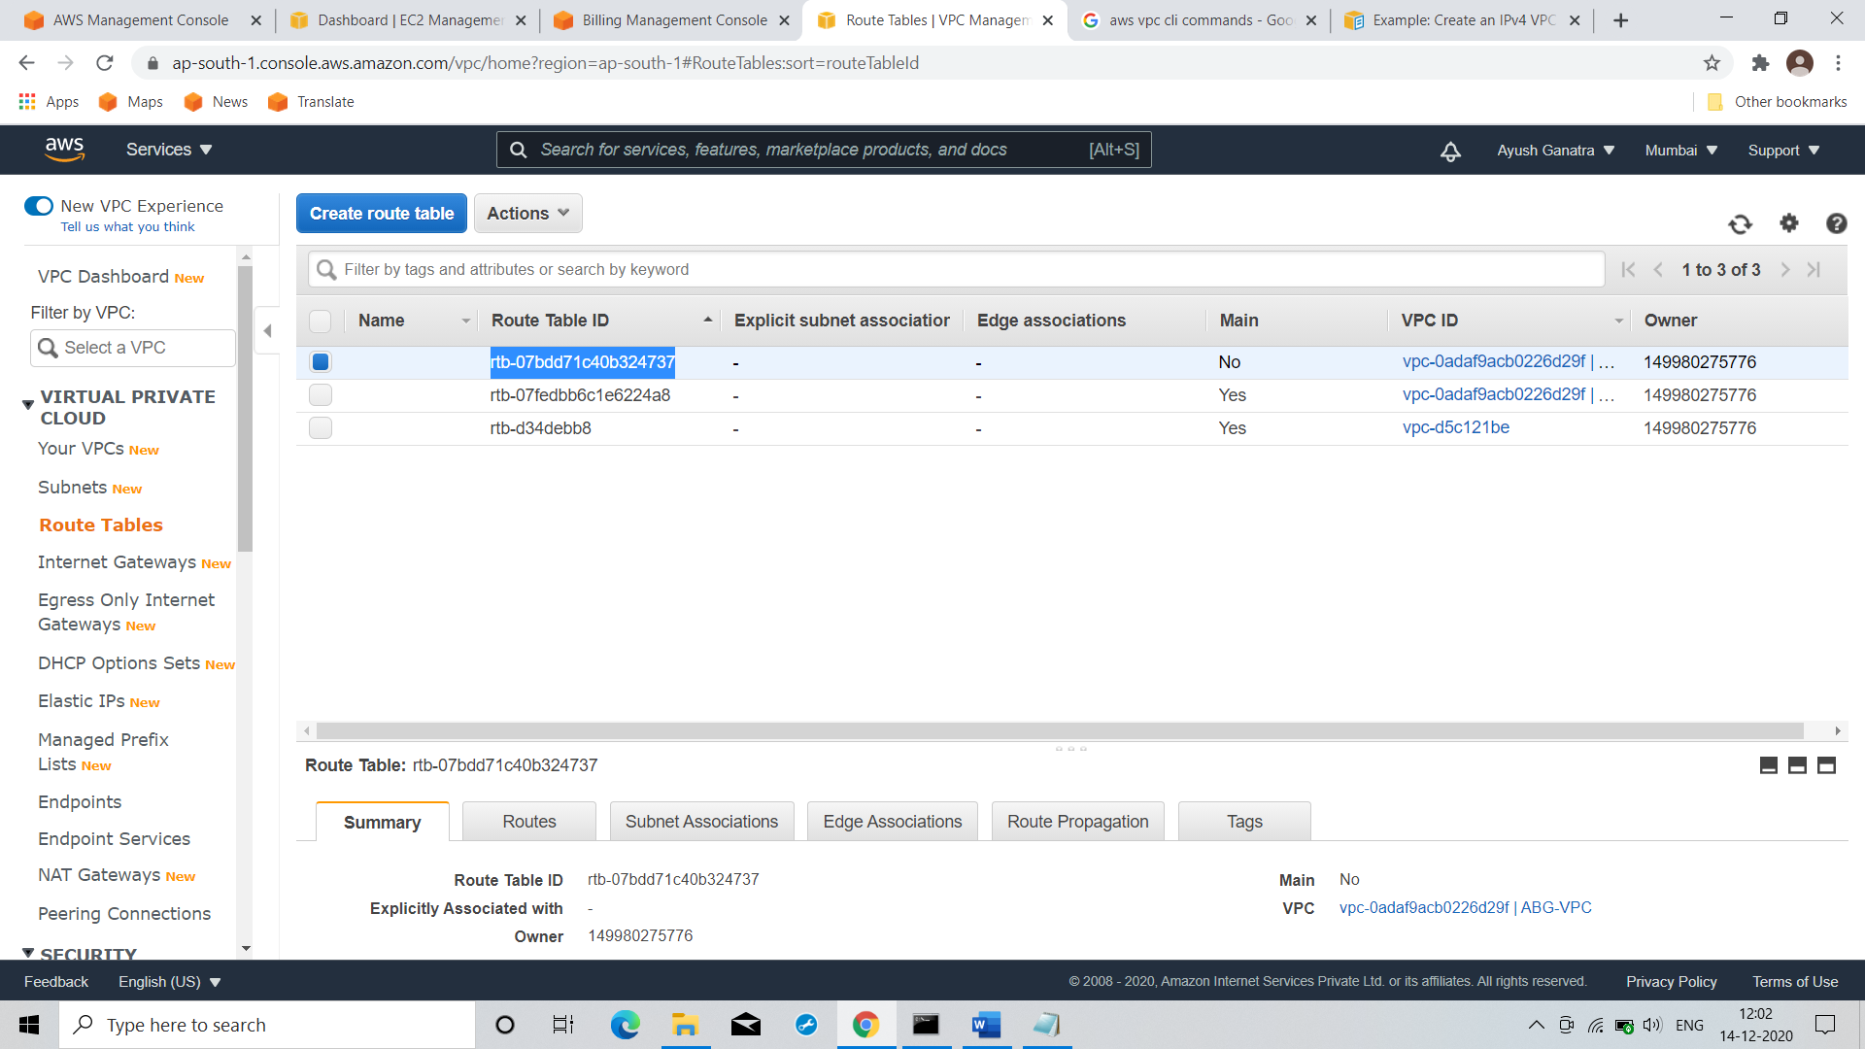

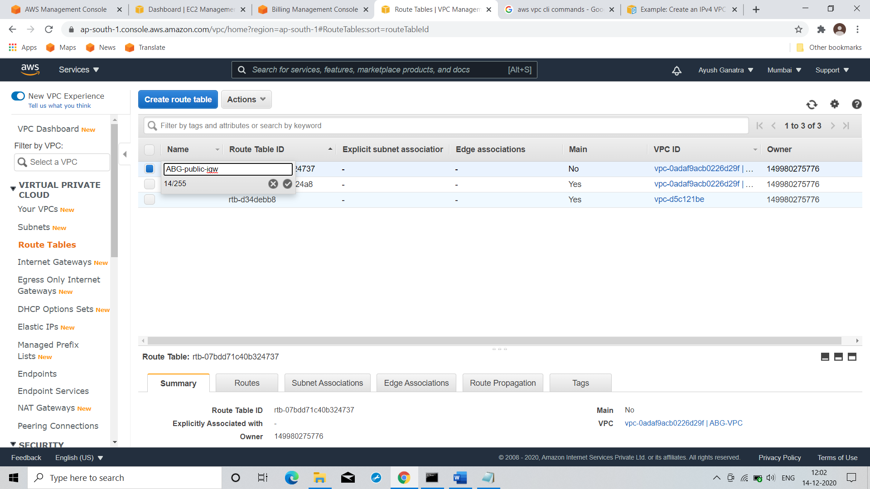

Command: aws ec2 create-route-table --vpc-id "vpc-0adaf9acb0226d29f"

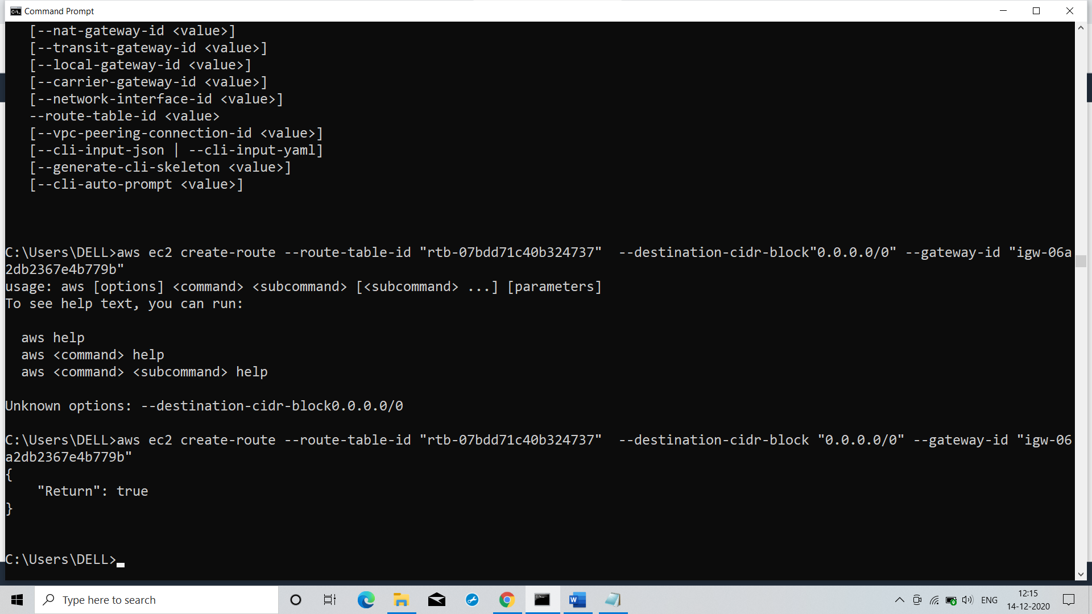

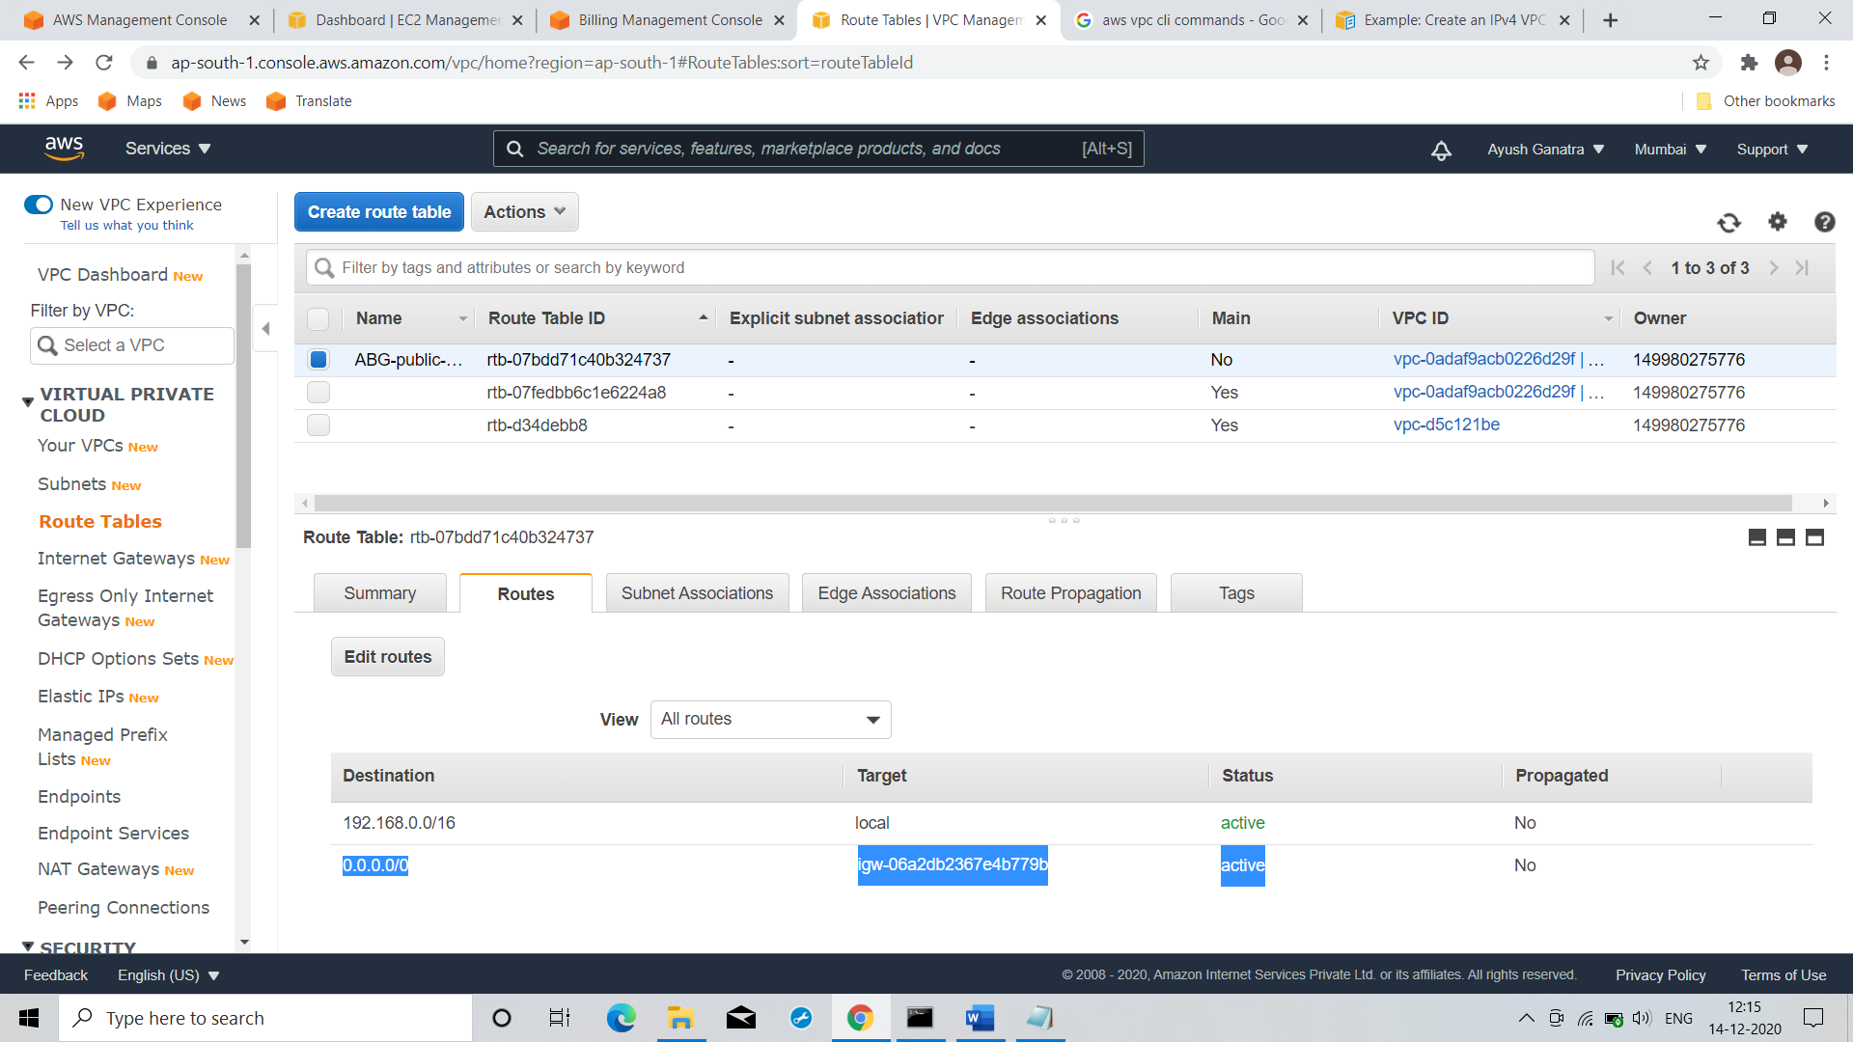

Command: aws ec2 create-route --route-table-id "rtb-07bdd71c40b324737" --destination-cidr-block "0.0.0.0/0" --gateway-id "igw-06a2db2367e4b779b"

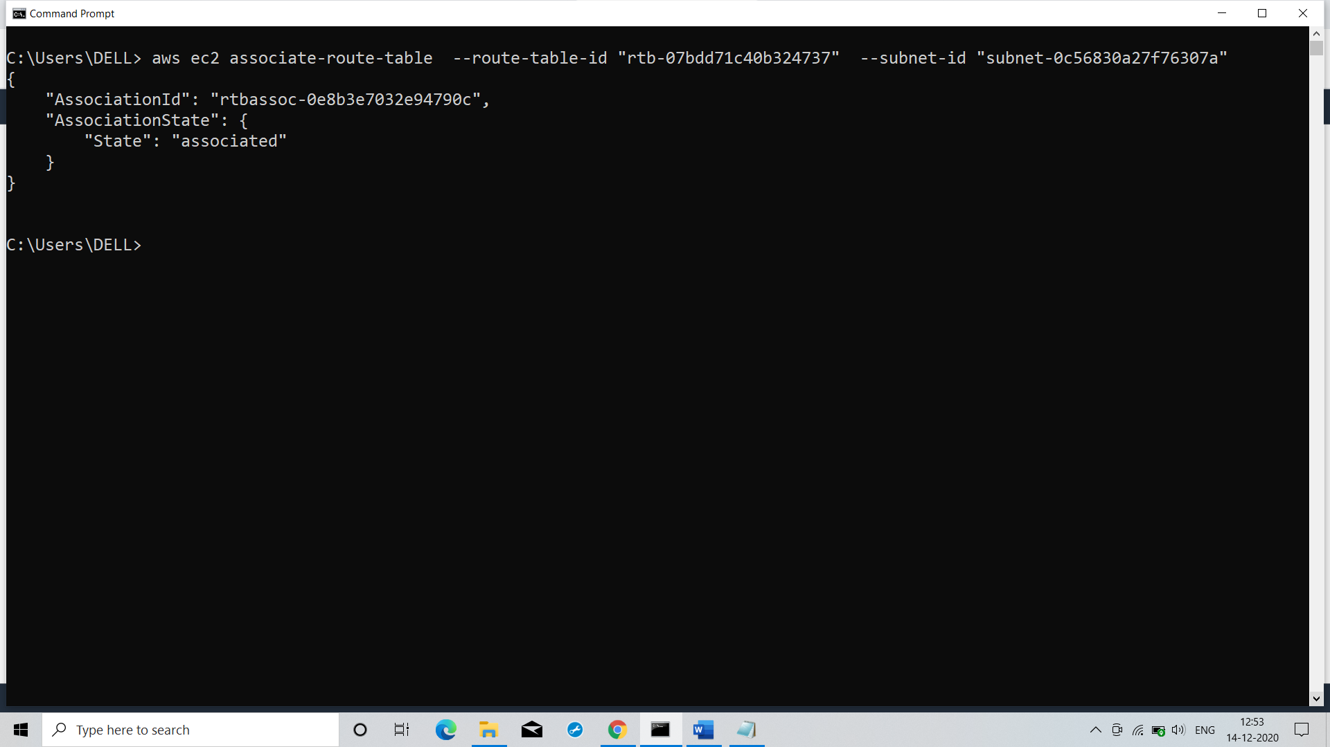

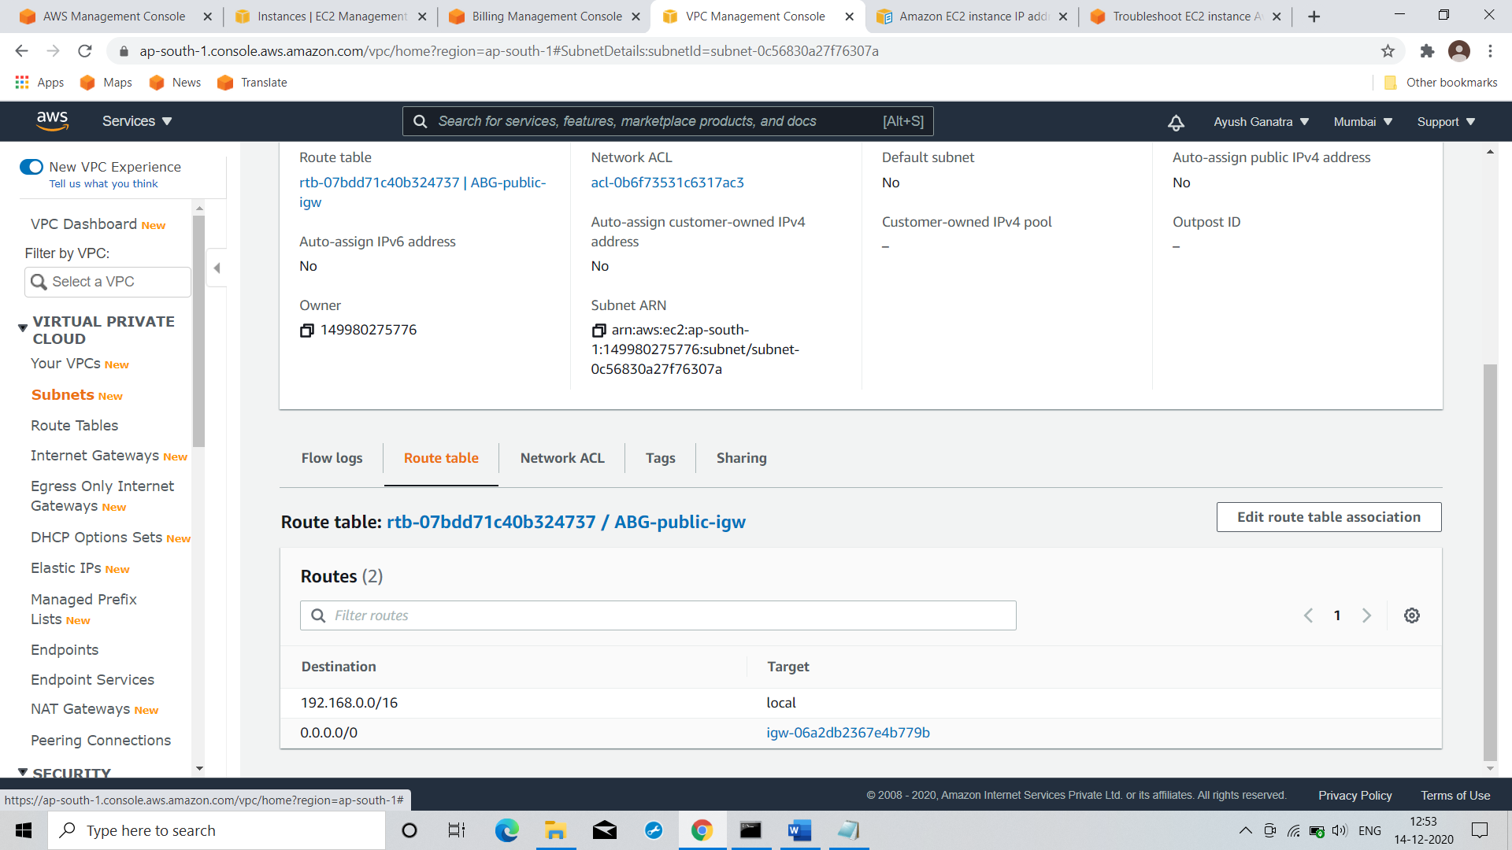

Command: aws ec2 associate-route-table --route-table-id "rtb-07bdd71c40b324737" --subnet-id "subnet-070ddd7dd9130dd63"

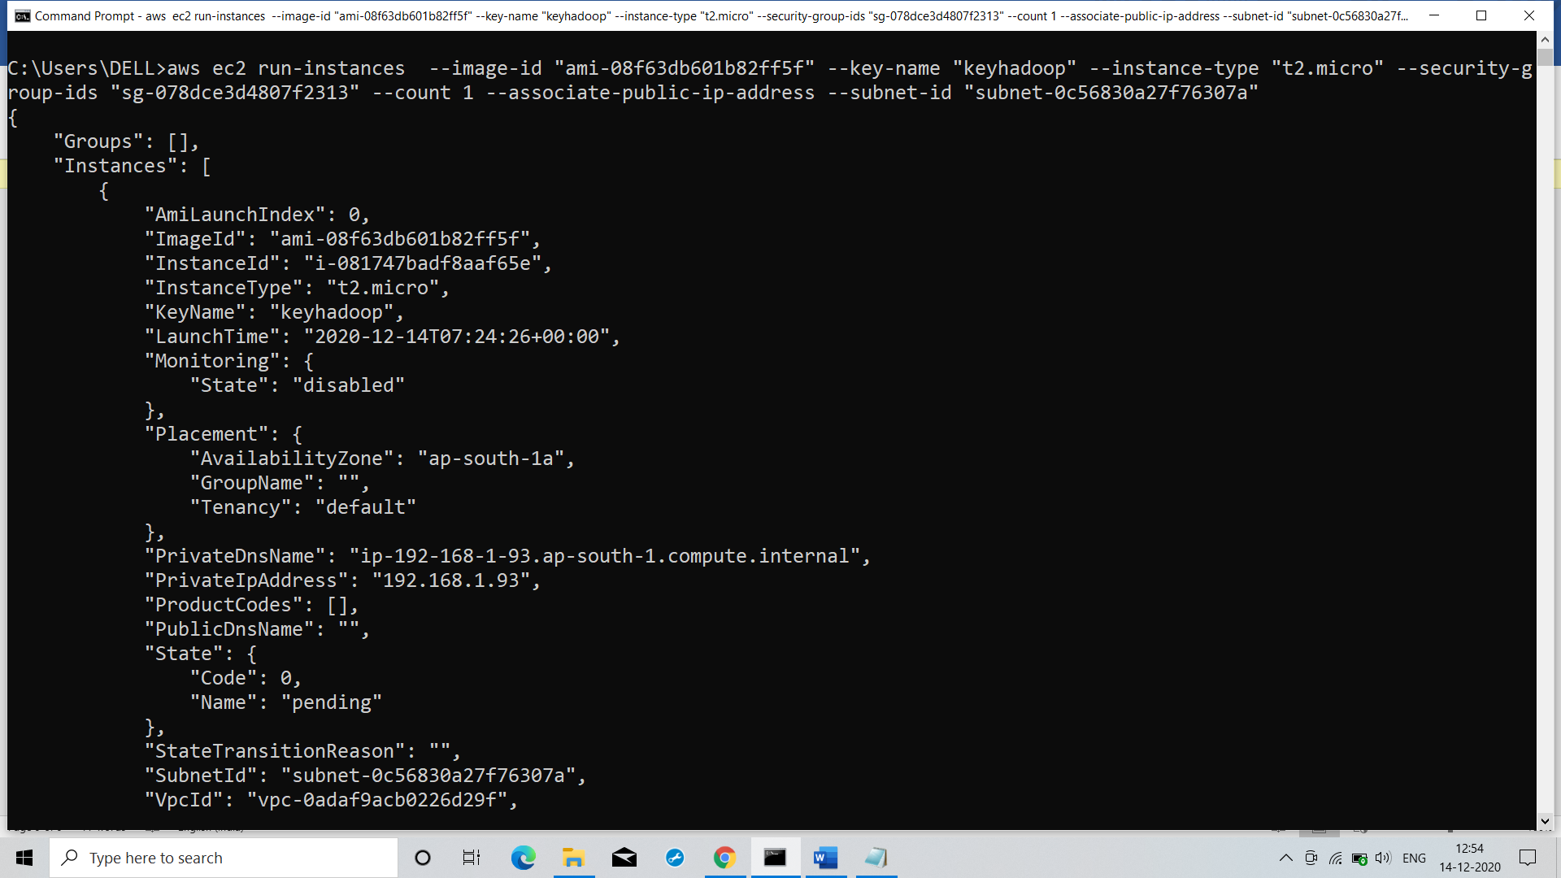

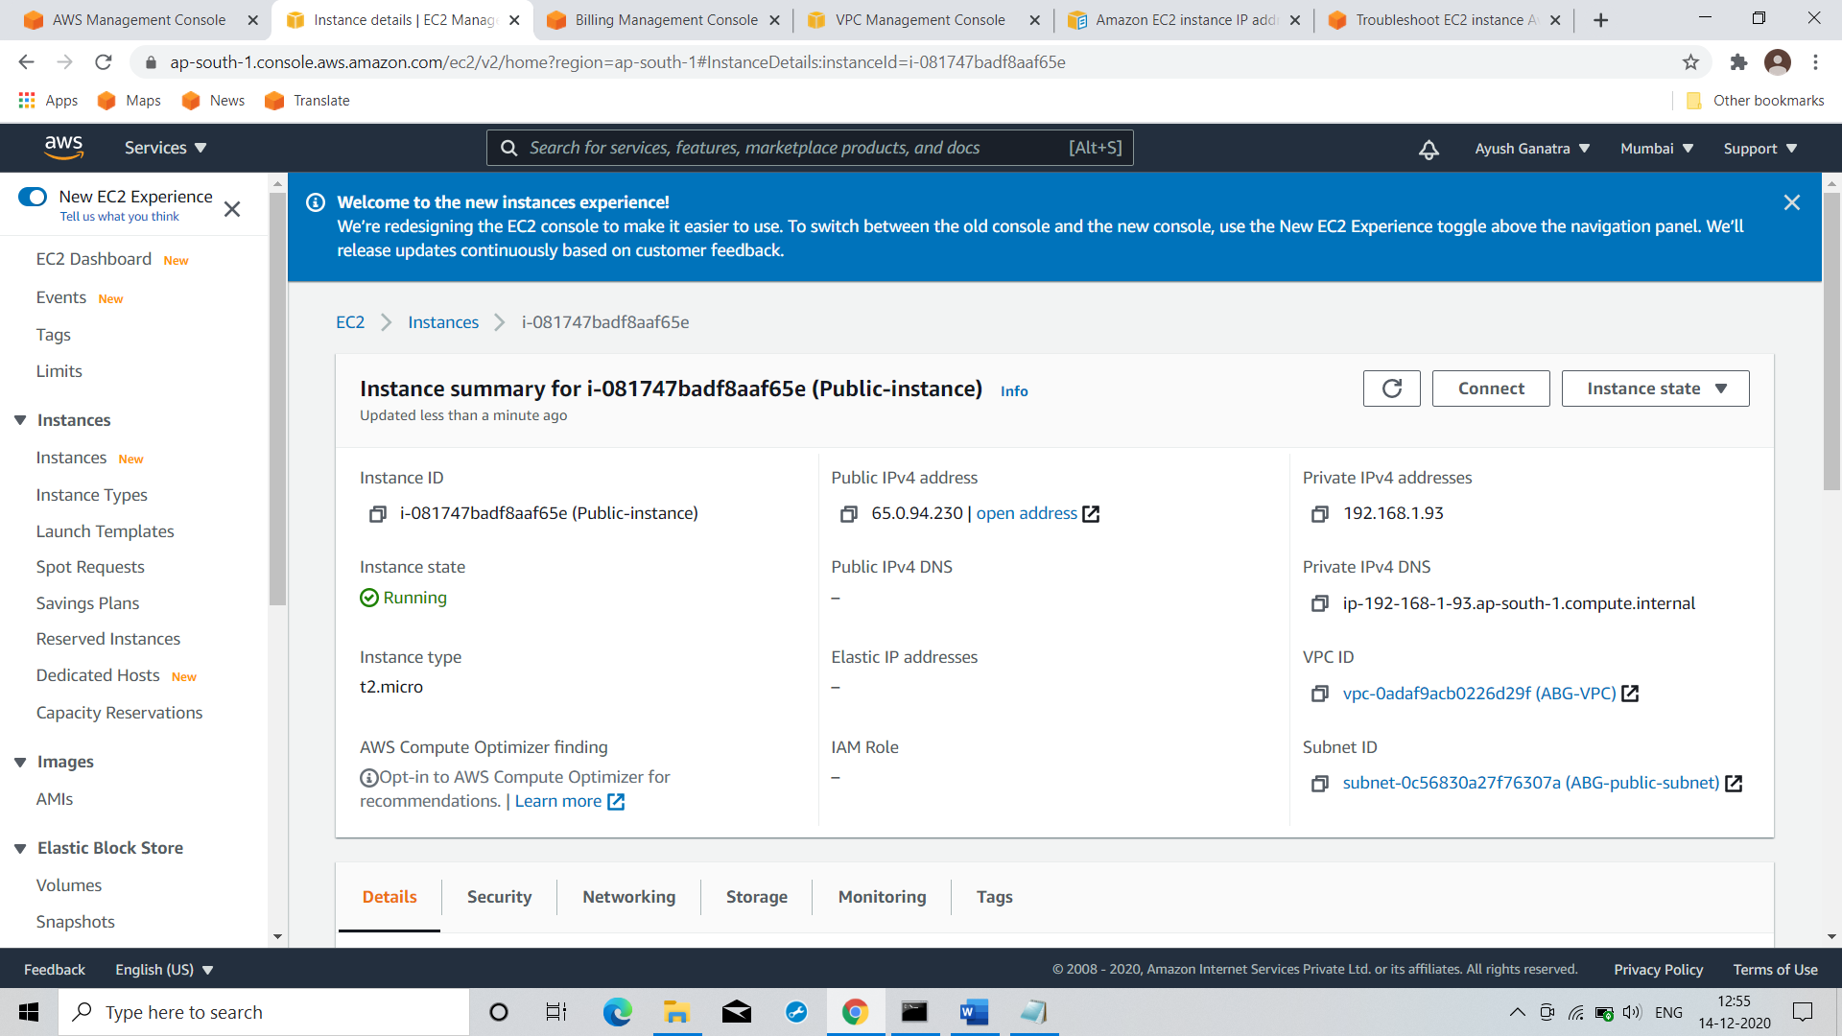

Command: aws ec2 run-instances --image-id "ami-08f63db601b82ff5f" --key-name "keyhadoop" --instance-type "t2.micro" --security-group-ids "sg-078dce3d4807f2313" --count 1 --associate-public-ip-address --subnet-id "subnet-0c56830a27f76307a"

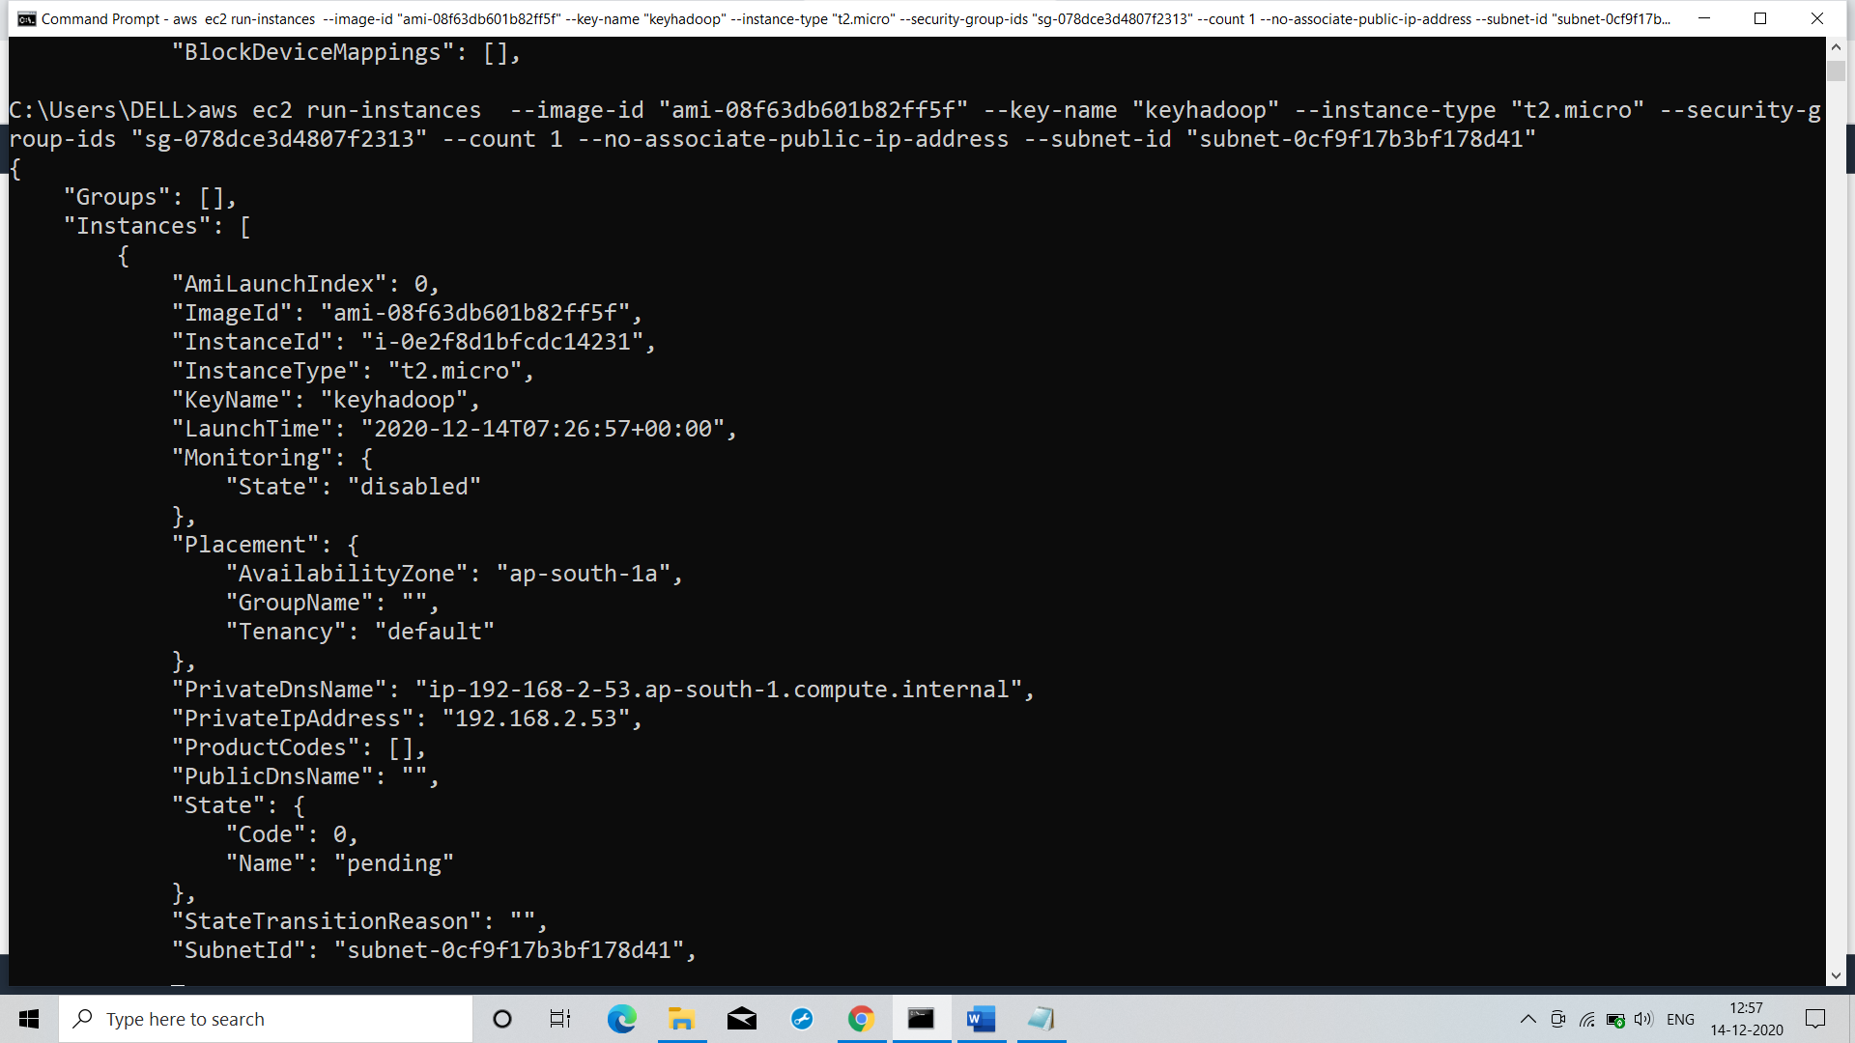

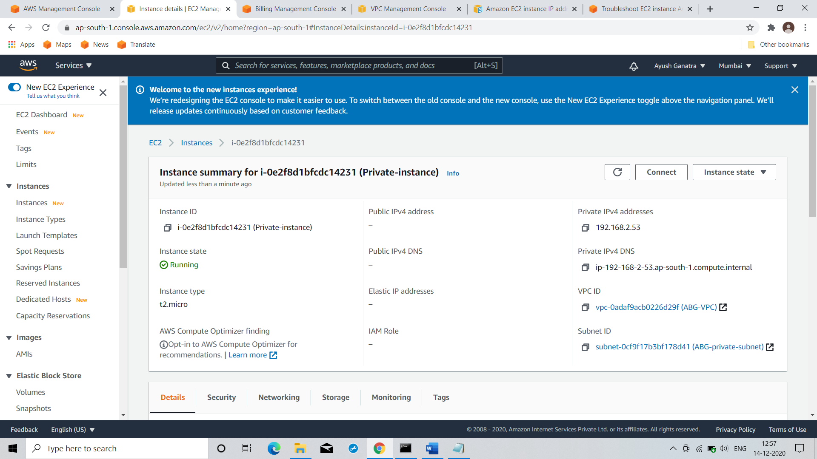

Command: aws ec2 run-instances --image-id "ami-08f63db601b82ff5f" --key-name "keyhadoop" --instance-type "t2.micro" --security-group-ids "sg-078dce3d4807f2313" --count 1 --no-associate-public-ip-address --subnet-id "subnet-0cf9f17b3bf178d41"

OS in public subnet:

Our instance in public subnet has connectivity to internet

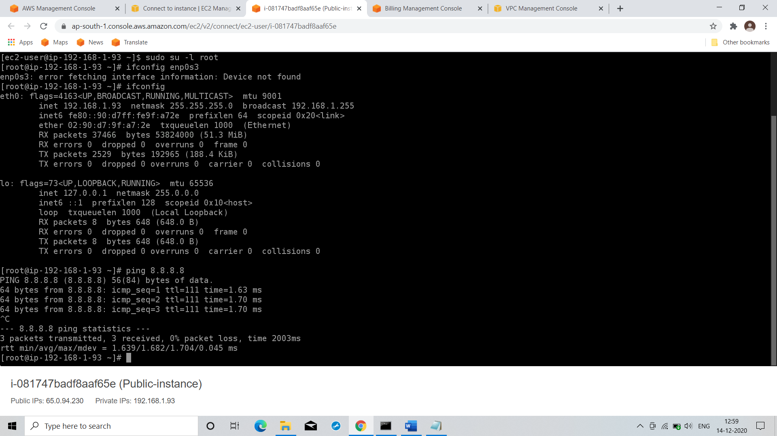

Public ip of OS is pingable from my base OS or Internet

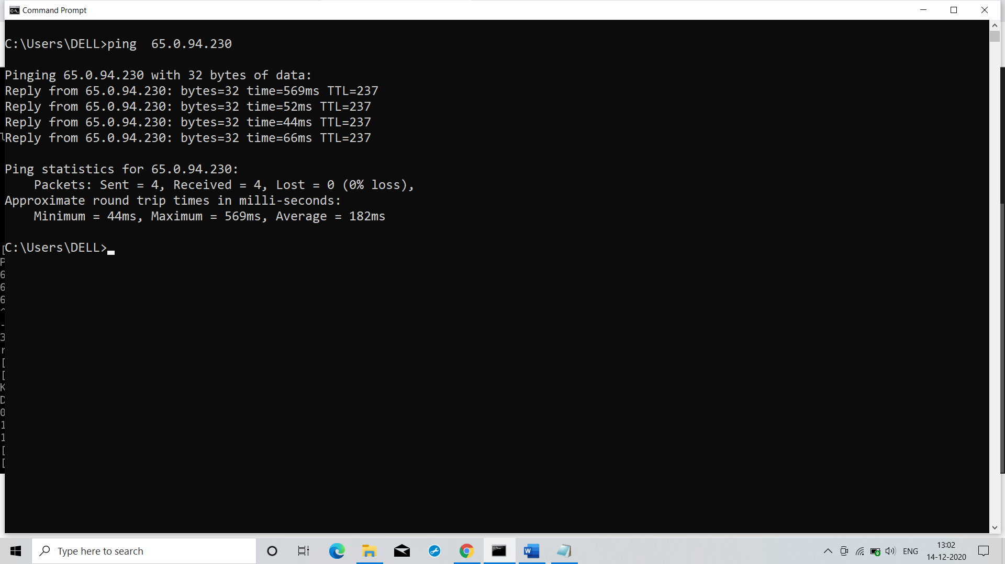

We cant directly connect instance in private subnet

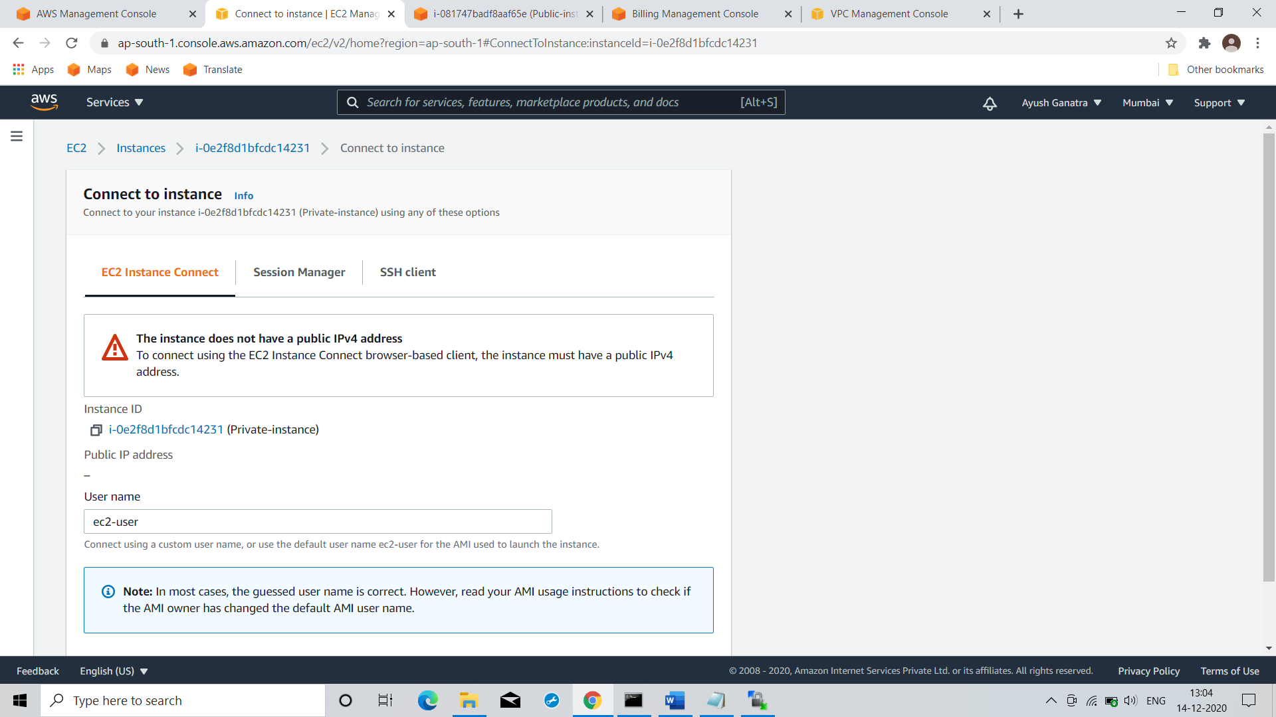

But it pingable(connected) from our instance in public subnet

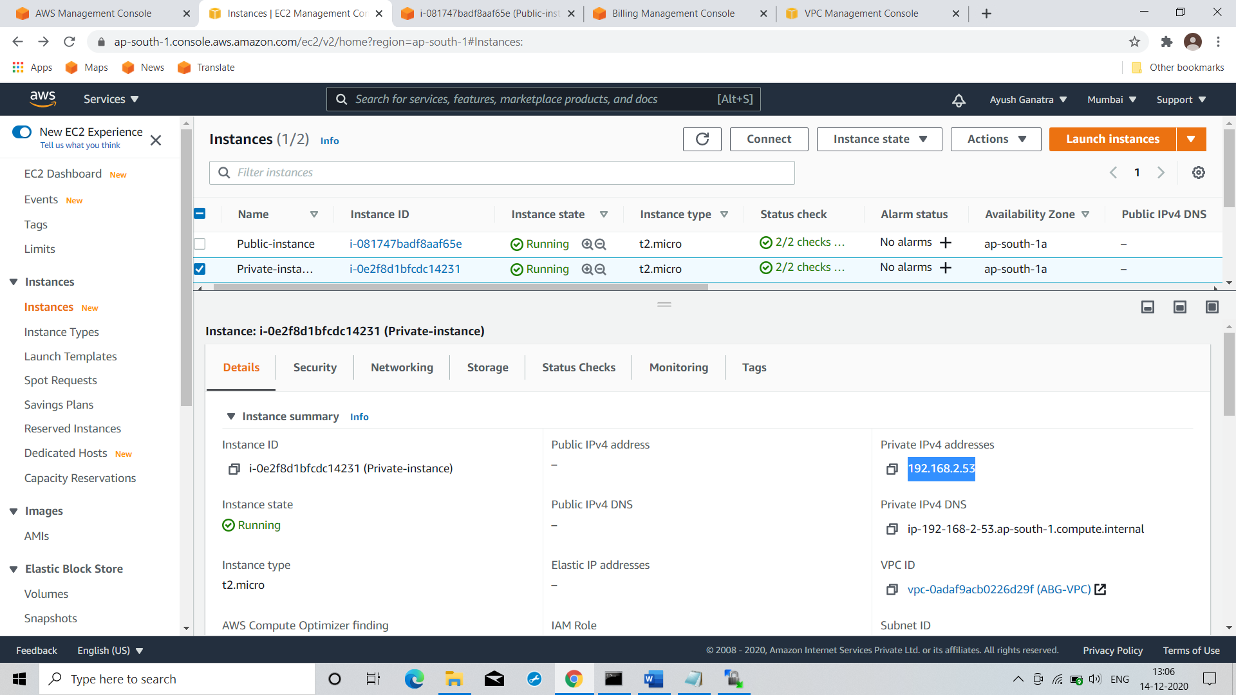

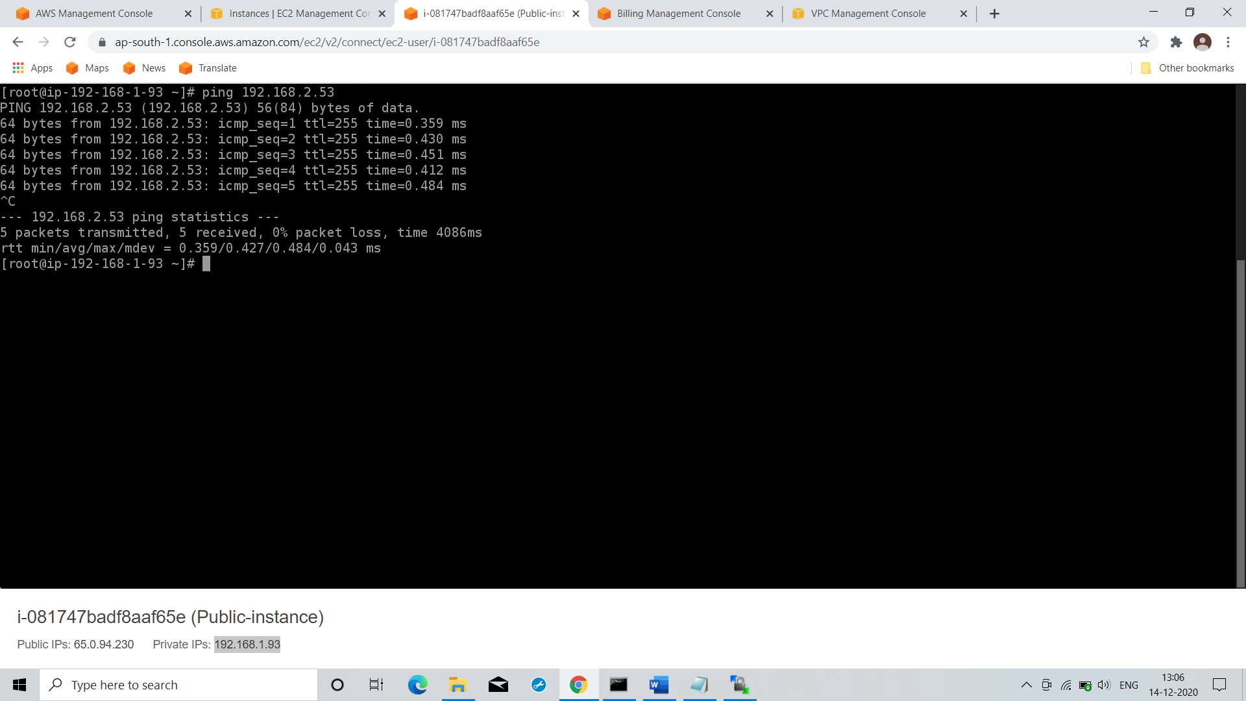

But we can do ssh from our instance in public subnet to instance in private subnet

Hence our instance in public subnet from which we did ssh to instance in private subnet is also called as Bastion host.

